
Hong Kong College of Technology Game Asset Development
(Assignment 1 - 30%)

- Group 4 (Members: Lam Man Ho, Li Shimin, Chau Chi Chung)
- Class Code: HDPMAGDF (2025)
- Class: Game asset development
- Date: 16/10/2025
- Tutor: Vincent Lam
- Reference/ project name: Wall Town "ramen bar”. Wall Town "ramen bar" - 3D model by BlackSpire (@blackspire) [34f5e16]



Brief Introduction:
It’s a cyberpunk feeling game scene. We chose this model for reference because of its complexity, also it met the assessment requirements due to its being an actual game scene. A suitable model for us to hone our skills. Here’s the glance of the original model comparing ours.
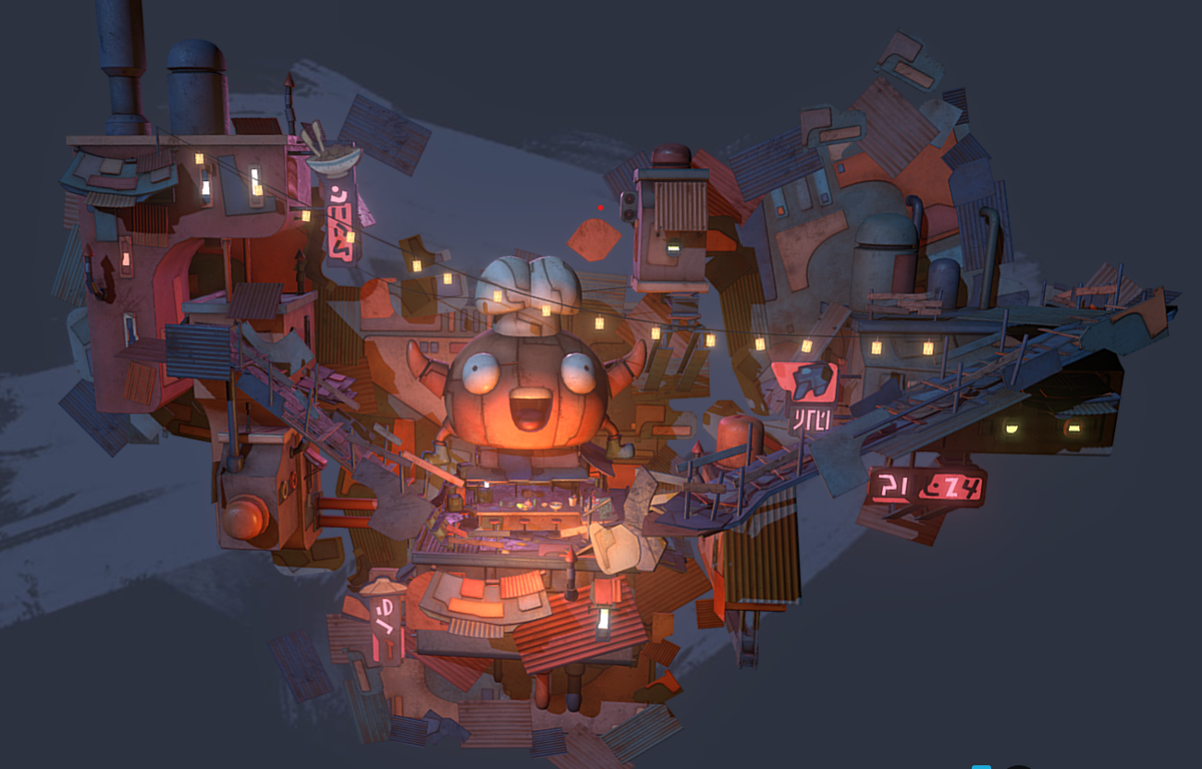
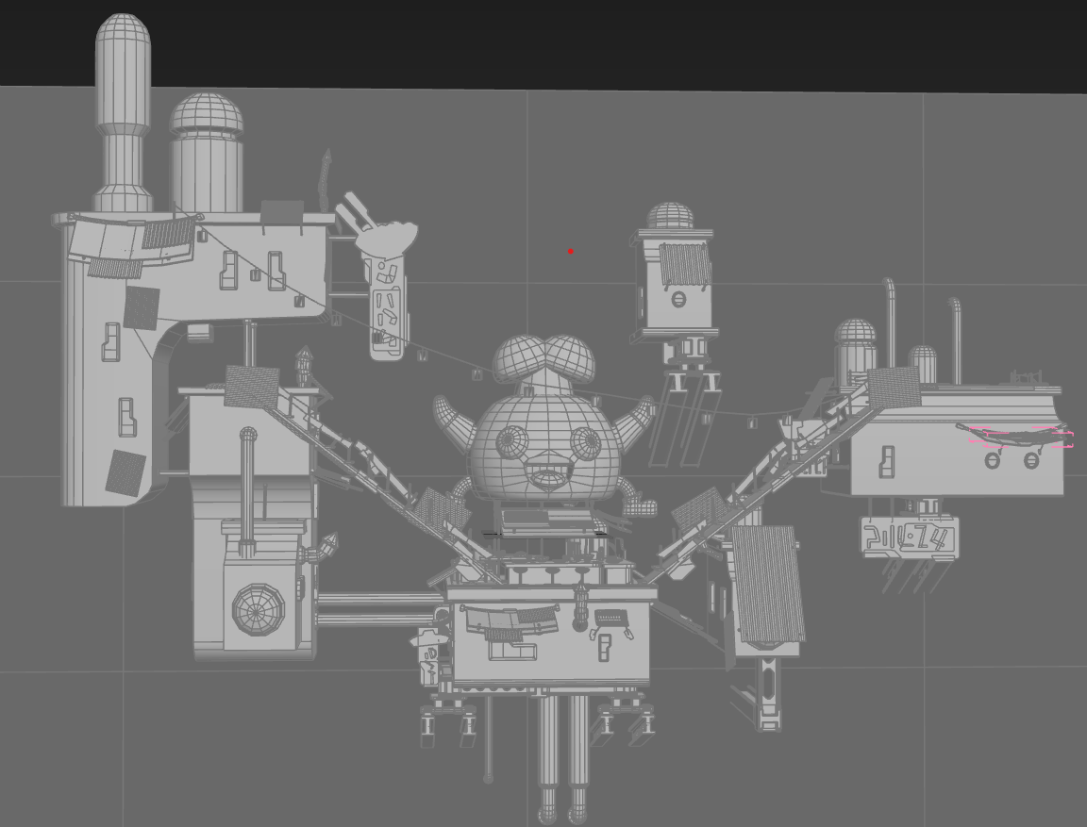

Collaboration:
We’ve divided the project into 3 parts so it’s easier to clarify work and collaborate. Here’s our responsibilities for the project. Li Shimin be responsible for middle part of the structure, Lam Man Ho be responsible for left side area, then Chau Chi Chung be responsible for the right side, as the picture shown below (Expect for some details).
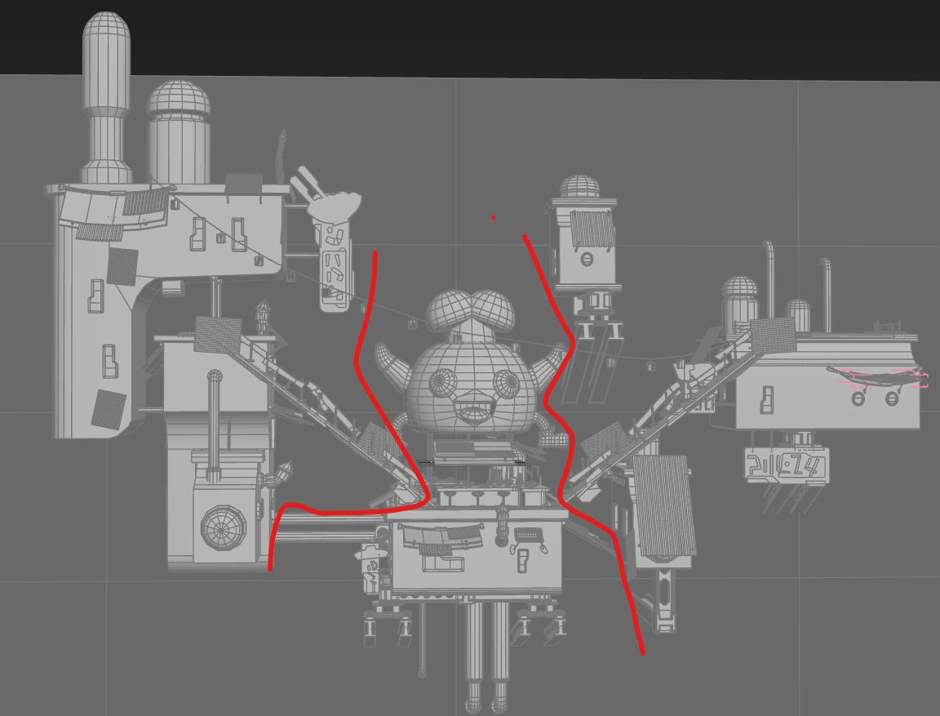
Therefore, this document will also be divided into three parts, each representing different individual’s work. Thank you.

**Will use ### as below to divide different individuals’ works.

Lam Man Ho:
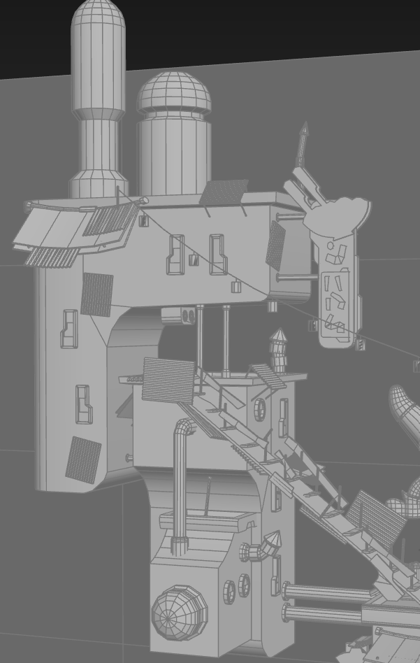
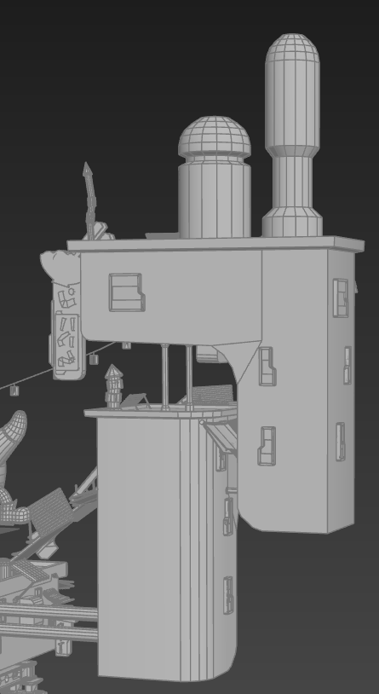

Left Structure Body:
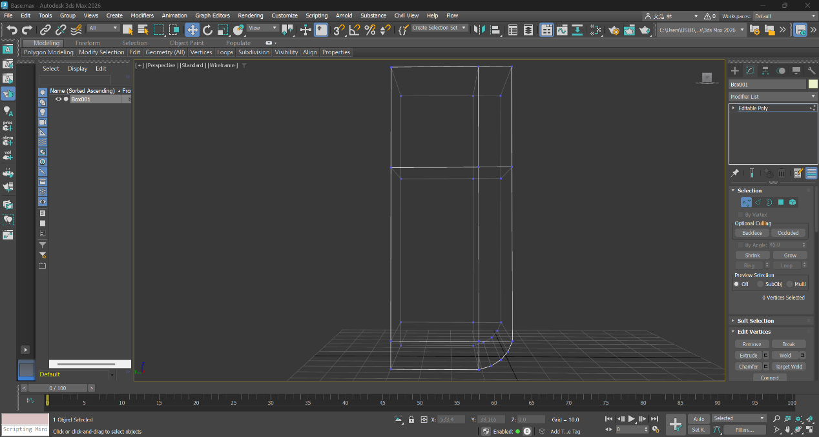
- Box
- Editable poly
- Move edges to suitable places
- Select corner edge, then chamfer
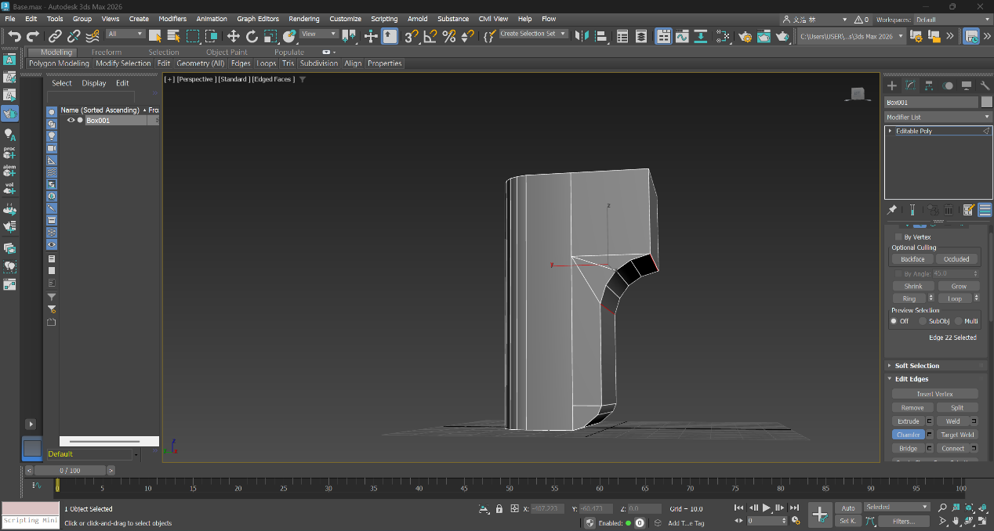
- Extrude top right polygon
- Chamfer their intersection edge
- Bevel and extrude to make rooftop
Windows:
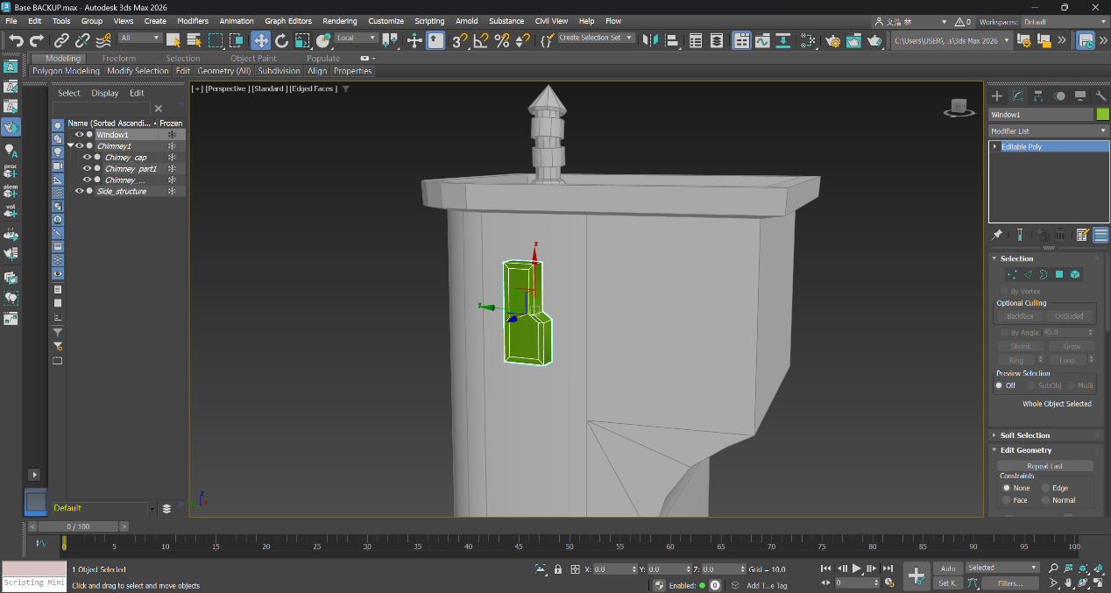
- Box, Editable ploy, “Connect” to make extra vertex and edges to manipulate the object into base shape
- Bevel but set height to 0, so it doesn’t extrude but created an extra inner polygon
- Using “Connect” to separate the inner polygon into three polygons, therefore we can extrude the polygons into different height
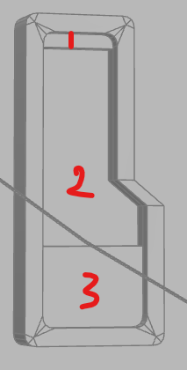

Chimneys:
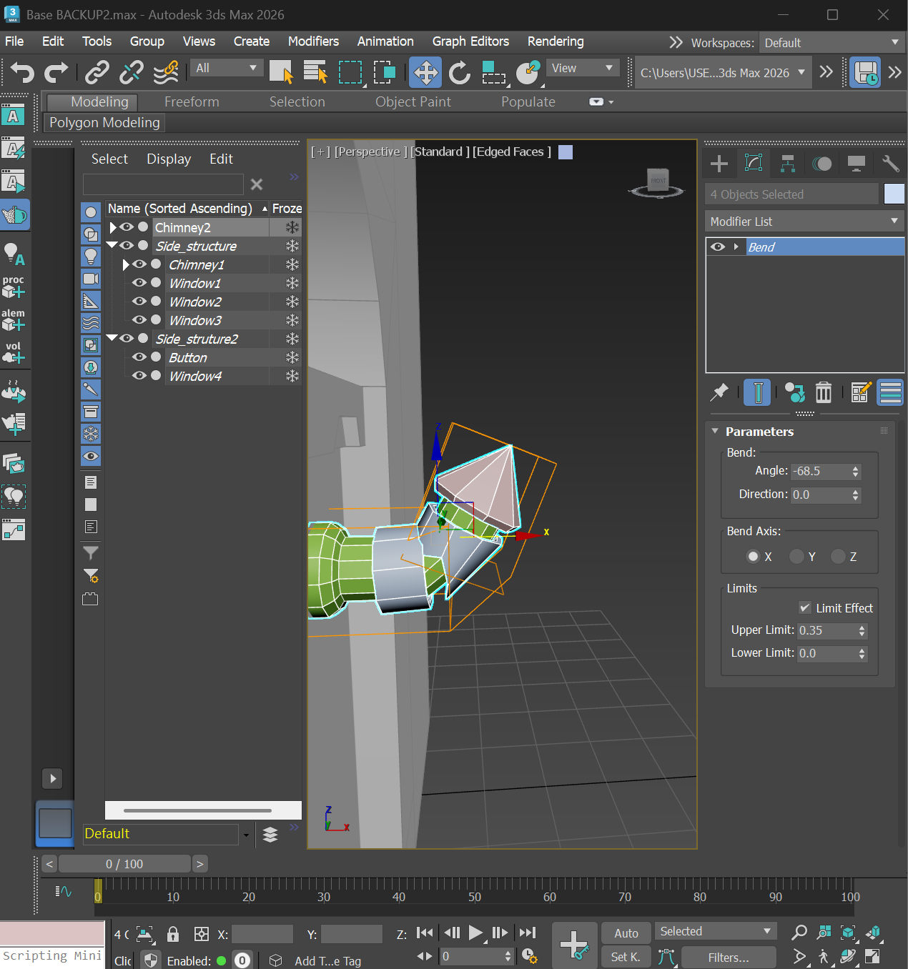
- Cylinder into editable poly, bevel to shrink and extrude, then extrude the middle polygon
- Adjust the polygon’s direction using E, then extrude again, so the cylinder can be extended to different directions.
- (Bend is optional, but it’s useful when we’re making a different set of the same item but facing other directions)
- Cylinder then pro-Boolean to subtract inside part to make the hollow cylinders
- Cylinder then editable poly, bevel the bottom polygon and using R to put together the vertices arounds the top polygon, “Weld” the vertices.

Structure 2 & 3 Bodies:
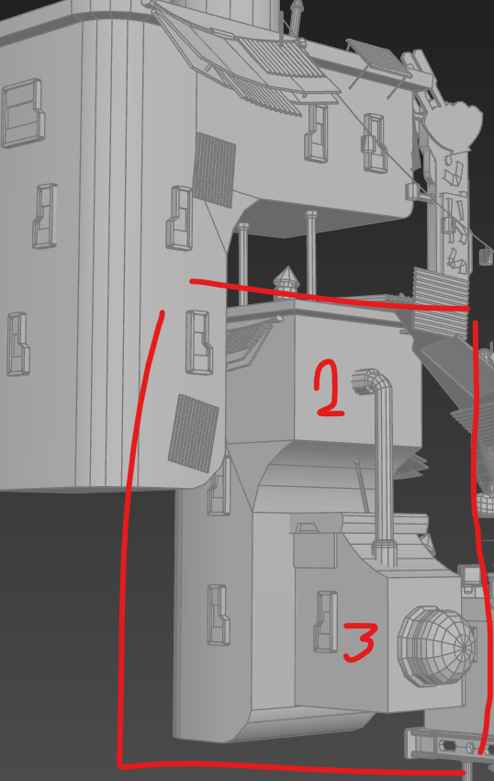
- Since structure 2 is quite similar to “Left Structure”, therefore I shift + w copies then adjust proportion
- For structure 3, box then chamfer top right edge
- Bevel but set height “0” to extend the polygon, then I extrude the new polygon to make the rooftop
- Chamfer the rooftop edge to smooth it
- Use pro-Boolean to subtract the side of rooftop and hollows it
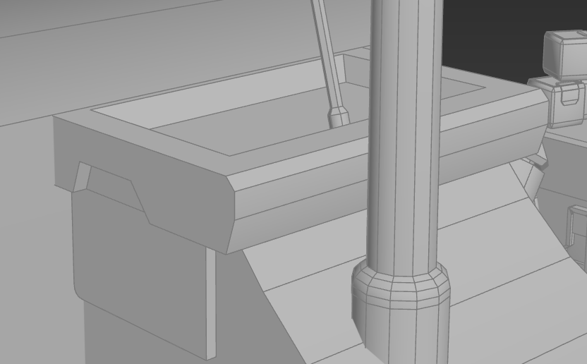
Button-like structure:
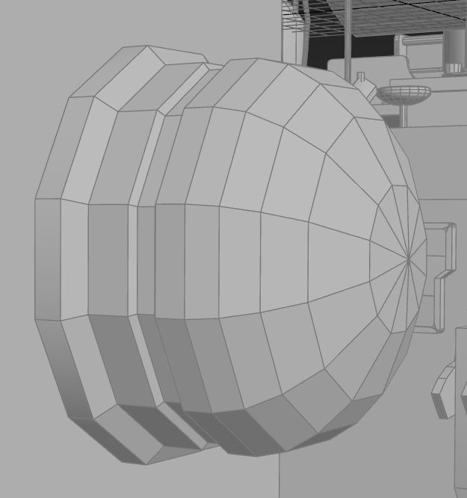
- Cylinder into editable ploy, “Bevel”& “Extrude” then finally, using R to put together the vertices arounds the top polygon, “Weld” the vertices.
Signboard:
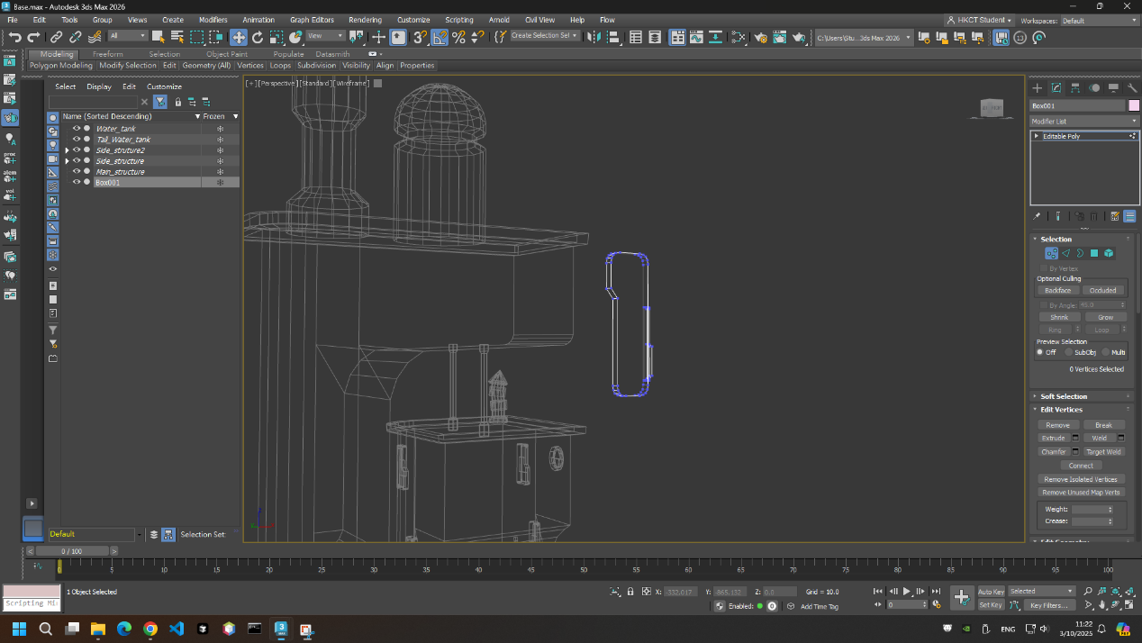
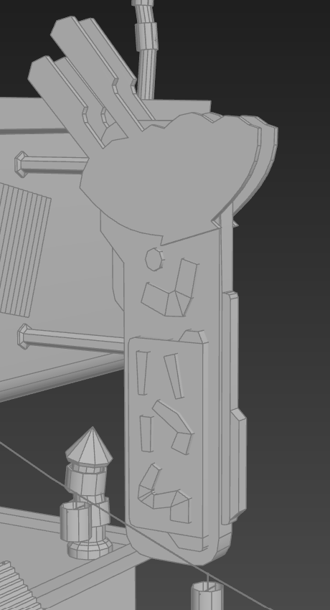

- Box then editable poly, adjust vertices or using “Connect” adding new vertices to make the base shape
- Chamfer edges
- Build addition boxes (editable poly), “Connect”, “Extrude” & “Bevel” to decorate the signboard
- I used boxes (editable poly) to make words on signboard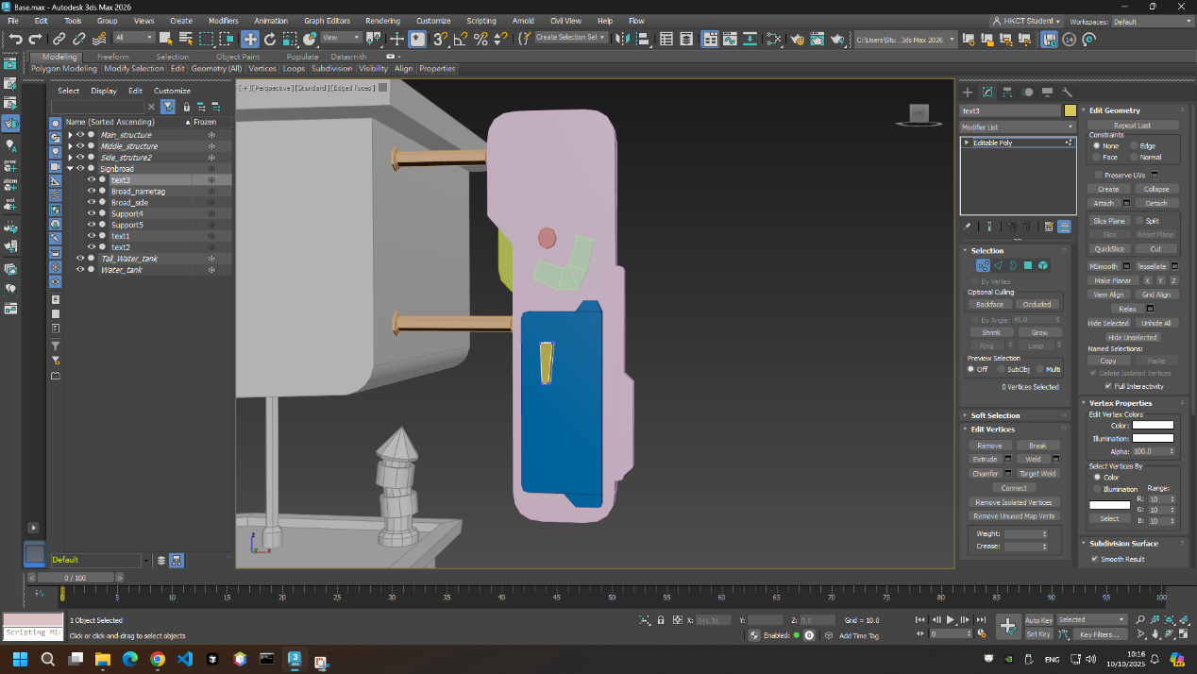
- Using “Line” to draw the shape of the ramen logo 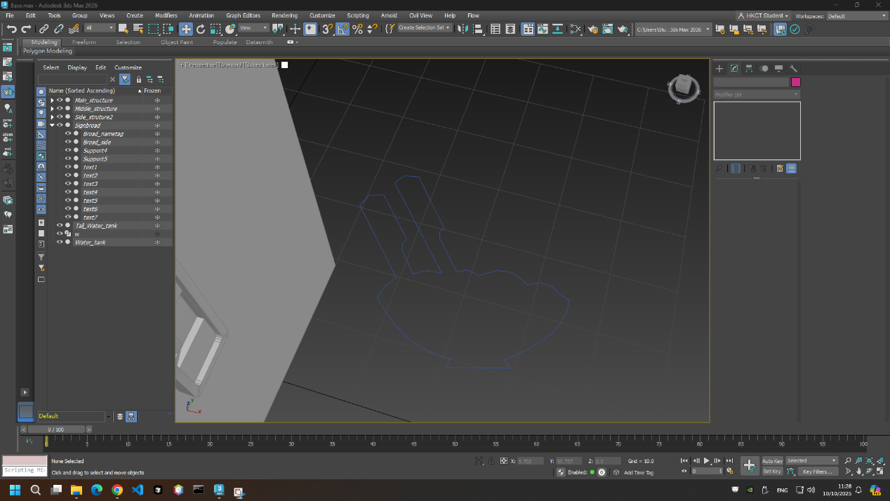
- Turn it into editable poly and extrude its upside polygon, however using this method will leave an empty polygon below
- Therefore, use “Cap” to cap the ramen logo

